Nursing Web App - Form Submission Test

**Objective:** To demonstrate the web app’s current form-submission capabilities, and to test whether data entered in the form is correctly reflected in the database.

The web app currently interfaces with the faculty table within the nursing database. That table contains the following fields, most of which correspond to a field in the form:

* ID (not present; auto-increments upon insertion into database)
* last_name
* first_name
* date_of_birth
* email_otterbein
* email_personal
* otterbein_id
* hire_date
* status (not present; calculated based on last year taught)
* exemption_needed
* exemption_sent
* last_semester_taught
* last_year_taught
* last_evaluation
* notes

# Test 1: Form Submission with All Fields Present

The simplest use-case is for entering a faculty member who has relevant information to enter in every field, though this is not necessarily the most common use-case.

Shown below is an instance of the faculty form with every field completed:

Upon clicking the “Create Faculty” button, the “Faculty successfully created” alert is received, indicating a successful insertion into the database.

After the alert is received, the new row is present in the faculty table, as shown below:

# 

Note that Professor Foley’s active status is listed as “0” or “false,” because she has not taught a course since 2019.

# Test 2: Form Submission without Exemption Letter

Another common use-case is for a faculty member who does not need an exemption letter, because they have an MSN and are teaching undergraduate-level courses, or because they have a DNP or PhD. In this case, the user would enter relevant values for all fields except for the “Exemption Letter Needed” and “Exemption Letter Sent On” fields, which they would leave blank.

Upon clicking the “Create Faculty” button, the “Faculty successfully created” alert is received, indicating a successful insertion into the database.

After the alert is received, the new row is present in the faculty table, as shown below:

Because the “Exemption Letter Needed” box was not checked, Dr. Descole’s exemption_needed field is listed as “0” or “false.” A NULL value is then entered in the exemption_sent field.

Note also that this faculty member’s active status is listed as “1” or “true,” because they have taught a course within the past two years.

# Test 3: Form Submission without Last Taught or Evaluation

Some faculty members being entered into the system may be new hires who have yet to teach a course or receive an evaluation. Thus, the “Last Semester Taught,” “Last Year Taught”, and “Last Evaluation” fields would be left unfilled, as shown below.

Upon clicking the “Create Faculty” button, the “Faculty successfully created” alert is received, indicating a successful insertion into the database.

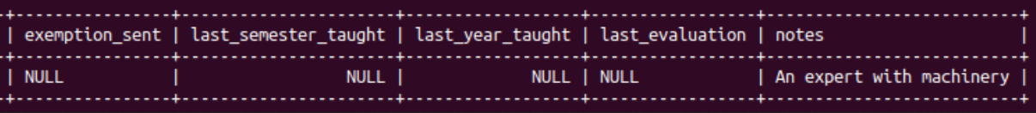After the alert is received, the new row is present in the faculty table, as shown below:

The last_semester_taught, last_year_taught, and last_evaluation fields have all been populated with a NULL value. Note also that this faculty member’s active status is “0” or “false,” because they have not yet begun teaching at Otterbein.